Steps to setup unity for play testing/visually inspecting game on mobile device w/o having to go through the hassle of fully building the app.

**Required:**

Unity Remote App - <https://play.google.com/store/apps/details?id=com.unity3d.genericremote>

Android SDK

**Mobile Setup:**

1. Install Unity Remote on device
2. Temporarily enable USB debugging on device when testing game. (Requires enabling android developer mode on device)

**Unity Setup:**

1. Setup Unity to build for Android
   1. File -> Build Settings -> Select Android under Platform then click switch platform.
2. Setup android devices for unity remote
   1. Edit -> Project Settings -> Editor tab -> under Device pick “any Android Device”
3. Restrict orientation to portrait since this game is being played in portrait mode

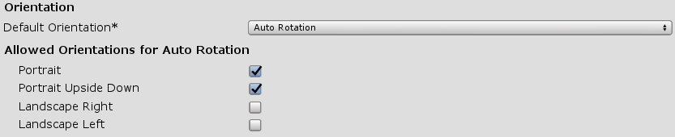

1. Set location of Android SDK
   1. Edit -> Preferences -> uncheck “Android SDK Tools Installed with Unity”
   2. Can try using the recommended Android SDK Tool with Unity but Unity Remote wasn’t working on my device, so I manually pointed it to the Android SDK I installed outside of Unity.

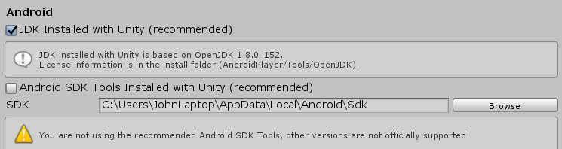

1. Using an aspect ratio of 16:9 for the game so just make sure the game window uses that in order to display the scene correctly. (Might have to use custom ratio/resolution here 480x800)

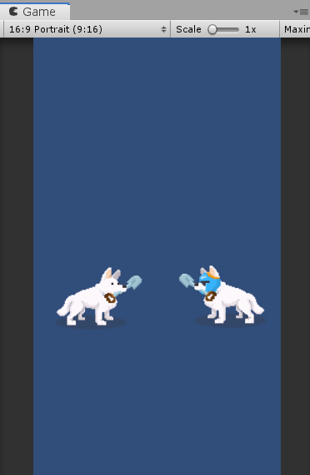

1. Make sure Unity Remote App is running and connected to the computer then hit “Play” in Unity. (If nothing shows on your phone try relaunching Unity)